Likelihood Examples

Example 7: Suppose Y_{i} ~ N(μ, σ ²) all i. In this case
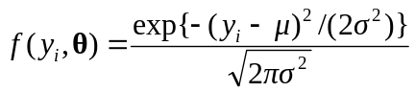 i = 1,2,...,n
Therefore the likelihood is the product of these
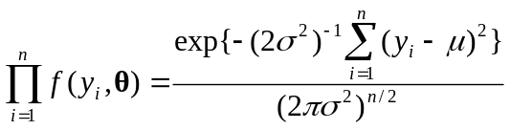

The loglikelihood is therefore
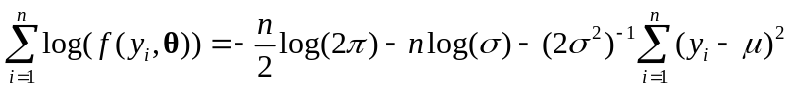

Example 8: Suppose Y_{i} ~ 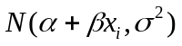, i = 1, 2, ..., n. The only difference from the previous example is that the μ depend on i. Thus the loglikelihood is:

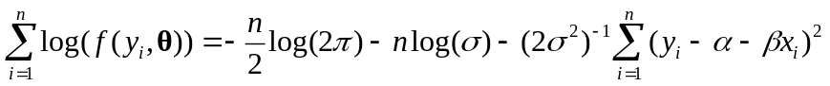

Bernoulli example: A Bernoulli random variable Y takes just two possible values 0 or 1:

Y = 1 with probability p
Y = 0 with probability (1 - p)

The likelihood is thus simply p if Y = 1, (1-p) if Y = 0

Thus for a sample Y_{i} ~ 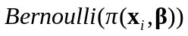 the likelihood is
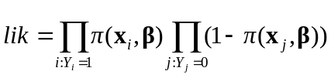
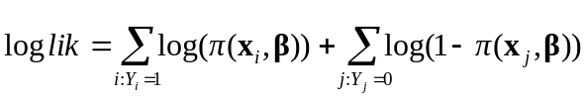

Regression example: This is very similar to the linear regression case:

